Object-Oriented Programming Homework

I2B28 王少雷

1. Source code:

package com.mycompany.notebook;

import java.awt.HeadlessException;

import java.io.BufferedWriter;

import java.io.File;

import java.io.FileNotFoundException;

import java.io.FileWriter;

import java.io.IOException;

import java.util.Scanner;

import java.util.logging.Level;

import java.util.logging.Logger;

import javax.swing.JFileChooser;

import javax.swing.JOptionPane;

import javax.swing.JTextArea;

import javax.swing.filechooser.FileNameExtensionFilter;

/**

*

* @author solom

*/

public class NewJFrame extends javax.swing.JFrame {

/**

* Creates new form NewJFrame

*/

public NewJFrame() {

initComponents();

}

/**

* This method is called from within the constructor to initialize the form.

* WARNING: Do NOT modify this code. The content of this method is always

* regenerated by the Form Editor.

*/

@SuppressWarnings("unchecked")

// <editor-fold defaultstate="collapsed" desc="Generated Code">

private void initComponents() {

jScrollPane1 = new javax.swing.JScrollPane();

editor = new javax.swing.JTextArea();

jMenuBar1 = new javax.swing.JMenuBar();

jMenu1 = new javax.swing.JMenu();

jMenuItem5 = new javax.swing.JMenuItem();

jMenuItem1 = new javax.swing.JMenuItem();

jMenuItem2 = new javax.swing.JMenuItem();

jMenuItem3 = new javax.swing.JMenuItem();

jMenu2 = new javax.swing.JMenu();

setDefaultCloseOperation(javax.swing.WindowConstants.EXIT_ON_CLOSE);

editor.setColumns(20);

editor.setRows(5);

jScrollPane1.setViewportView(editor);

jMenu1.setText("File");

jMenuItem5.setAccelerator(javax.swing.KeyStroke.getKeyStroke(java.awt.event.KeyEvent.VK_N, java.awt.event.InputEvent.CTRL_DOWN_MASK));

jMenuItem5.setText("New File");

jMenuItem5.addActionListener(new java.awt.event.ActionListener() {

public void actionPerformed(java.awt.event.ActionEvent evt) {

jMenuItem5ActionPerformed(evt);

}

});

jMenu1.add(jMenuItem5);

jMenuItem1.setAccelerator(javax.swing.KeyStroke.getKeyStroke(java.awt.event.KeyEvent.VK_O, java.awt.event.InputEvent.CTRL_DOWN_MASK));

jMenuItem1.setText("Open File");

jMenuItem1.addActionListener(new java.awt.event.ActionListener() {

public void actionPerformed(java.awt.event.ActionEvent evt) {

jMenuItem1ActionPerformed(evt);

}

});

jMenu1.add(jMenuItem1);

jMenuItem2.setAccelerator(javax.swing.KeyStroke.getKeyStroke(java.awt.event.KeyEvent.VK_S, java.awt.event.InputEvent.CTRL_DOWN_MASK));

jMenuItem2.setText("Save File");

jMenuItem2.addActionListener(new java.awt.event.ActionListener() {

public void actionPerformed(java.awt.event.ActionEvent evt) {

jMenuItem2ActionPerformed(evt);

}

});

jMenu1.add(jMenuItem2);

jMenuItem3.setAccelerator(javax.swing.KeyStroke.getKeyStroke(java.awt.event.KeyEvent.VK_F12, 0));

jMenuItem3.setLabel("Save as");

jMenuItem3.addActionListener(new java.awt.event.ActionListener() {

public void actionPerformed(java.awt.event.ActionEvent evt) {

jMenuItem3ActionPerformed(evt);

}

});

jMenu1.add(jMenuItem3);

jMenuItem3.getAccessibleContext().setAccessibleName("Save as");

jMenuBar1.add(jMenu1);

jMenu2.setText("Edit");

jMenuBar1.add(jMenu2);

setJMenuBar(jMenuBar1);

javax.swing.GroupLayout layout = new javax.swing.GroupLayout(getContentPane());

getContentPane().setLayout(layout);

layout.setHorizontalGroup(

layout.createParallelGroup(javax.swing.GroupLayout.Alignment.LEADING)

.addComponent(jScrollPane1, javax.swing.GroupLayout.Alignment.TRAILING, javax.swing.GroupLayout.DEFAULT_SIZE, 400, Short.MAX_VALUE)

);

layout.setVerticalGroup(

layout.createParallelGroup(javax.swing.GroupLayout.Alignment.LEADING)

.addComponent(jScrollPane1, javax.swing.GroupLayout.Alignment.TRAILING, javax.swing.GroupLayout.DEFAULT_SIZE, 277, Short.MAX_VALUE)

);

pack();

}// </editor-fold>

JFileChooser chooser = null;

int isSave = 0;

String text = null;

private void jMenuItem1ActionPerformed(java.awt.event.ActionEvent evt) {

openDialog();

}

private void jMenuItem2ActionPerformed(java.awt.event.ActionEvent evt) {

// TODO add your handling code here:

FileWriter fw = null;

if(chooser!=null){

try {

fw = new FileWriter(chooser.getSelectedFile());

fw.write(this.editor.getText());

fw.close();

} catch (IOException ex) {

Logger.getLogger(NewJFrame.class.getName()).log(Level.SEVERE, null, ex);

}

}else{

SaveDialog();

}

}

private void jMenuItem3ActionPerformed(java.awt.event.ActionEvent evt) {

SaveDialog();

}

private void jMenuItem5ActionPerformed(java.awt.event.ActionEvent evt) {

// TODO add your handling code here:

if(chooser!=null&&text!=null){

int res=JOptionPane.showConfirmDialog(null, "Do you want to save your file?", "You don't save your file", JOptionPane.YES_NO_OPTION);

if(res==JOptionPane.YES_OPTION){

SaveDialog(); //點選“是”後執行這個程式碼塊

}else if(res==JOptionPane.NO_OPTION){

chooser = null;

editor.setText("");

text = null;

}

}else{

chooser = null;

editor.setText("");

text = null;

}

}

private void SaveDialog() throws HeadlessException {

// TODO add your handling code here:

FileWriter fw = null;

JFileChooser choose = new JFileChooser();

FileNameExtensionFilter filter = new FileNameExtensionFilter(

"txt&Text", "txt", "Text");

choose.setCurrentDirectory(new File("/home/me/Documents"));

int returnVal = choose.showSaveDialog(null);

if(returnVal == JFileChooser.APPROVE_OPTION) {

try {

fw = new FileWriter(choose.getSelectedFile()+".txt");

fw.write(this.editor.getText());

fw.close();

} catch (IOException ex) {

Logger.getLogger(NewJFrame.class.getName()).log(Level.SEVERE, null, ex);

}

}

}

private void openDialog() throws HeadlessException {

// TODO add your handling code here:

chooser = new JFileChooser();

String text = null;

FileNameExtensionFilter filter = new FileNameExtensionFilter(

"txt&Text", "txt", "Text");

chooser.setFileFilter(filter);

int returnVal = chooser.showOpenDialog(this);

if(returnVal == JFileChooser.APPROVE_OPTION) {

System.out.println("You chose to open this file: " +chooser.getSelectedFile().getName());

text = OpenFile(chooser.getSelectedFile());

this.editor.setText(text);

}

}

public String OpenFile(File myObj){

StringBuilder sb = new StringBuilder();

try {

Scanner myReader = new Scanner(myObj);

while (myReader.hasNextLine()) {

String data = myReader.nextLine();

System.out.println(data);

sb.append(data+"\n");

}

myReader.close();

} catch (FileNotFoundException e) {

System.out.println("An error occurred.");

e.printStackTrace();

}

return sb.toString();

}

/**

* @param args the command line arguments

*/

public static void main(String args[]) {

/* Set the Nimbus look and feel */

//<editor-fold defaultstate="collapsed" desc=" Look and feel setting code (optional) ">

/* If Nimbus (introduced in Java SE 6) is not available, stay with the default look and feel.

* For details see http://download.oracle.com/javase/tutorial/uiswing/lookandfeel/plaf.html

*/

try {

for (javax.swing.UIManager.LookAndFeelInfo info : javax.swing.UIManager.getInstalledLookAndFeels()) {

if ("Nimbus".equals(info.getName())) {

javax.swing.UIManager.setLookAndFeel(info.getClassName());

break;

}

}

} catch (ClassNotFoundException ex) {

java.util.logging.Logger.getLogger(NewJFrame.class.getName()).log(java.util.logging.Level.SEVERE, null, ex);

} catch (InstantiationException ex) {

java.util.logging.Logger.getLogger(NewJFrame.class.getName()).log(java.util.logging.Level.SEVERE, null, ex);

} catch (IllegalAccessException ex) {

java.util.logging.Logger.getLogger(NewJFrame.class.getName()).log(java.util.logging.Level.SEVERE, null, ex);

} catch (javax.swing.UnsupportedLookAndFeelException ex) {

java.util.logging.Logger.getLogger(NewJFrame.class.getName()).log(java.util.logging.Level.SEVERE, null, ex);

}

//</editor-fold>

/* Create and display the form */

java.awt.EventQueue.invokeLater(new Runnable() {

public void run() {

NewJFrame Frame = new NewJFrame();

Frame.setVisible(true);

Frame.setTitle("Editor by Java");

}

});

}

// Variables declaration - do not modify

private javax.swing.JTextArea editor;

private javax.swing.JMenu jMenu1;

private javax.swing.JMenu jMenu2;

private javax.swing.JMenuBar jMenuBar1;

private javax.swing.JMenuItem jMenuItem1;

private javax.swing.JMenuItem jMenuItem2;

private javax.swing.JMenuItem jMenuItem3;

private javax.swing.JMenuItem jMenuItem5;

private javax.swing.JScrollPane jScrollPane1;

// End of variables declaration

}

2.

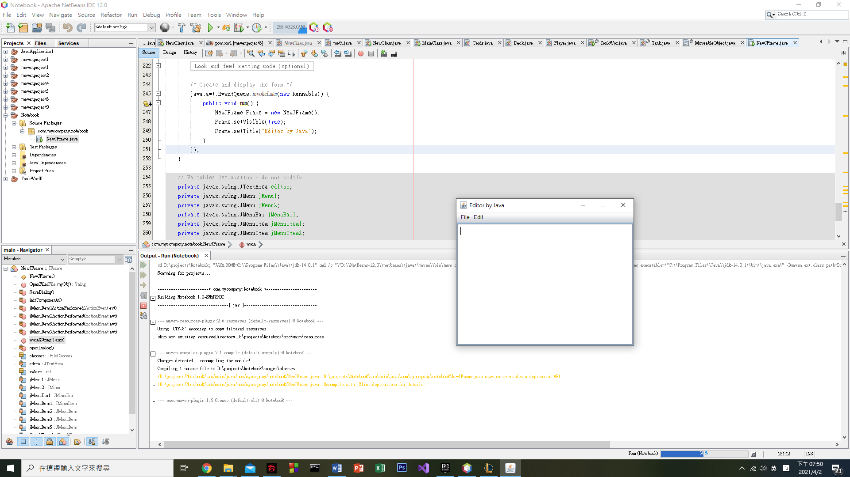

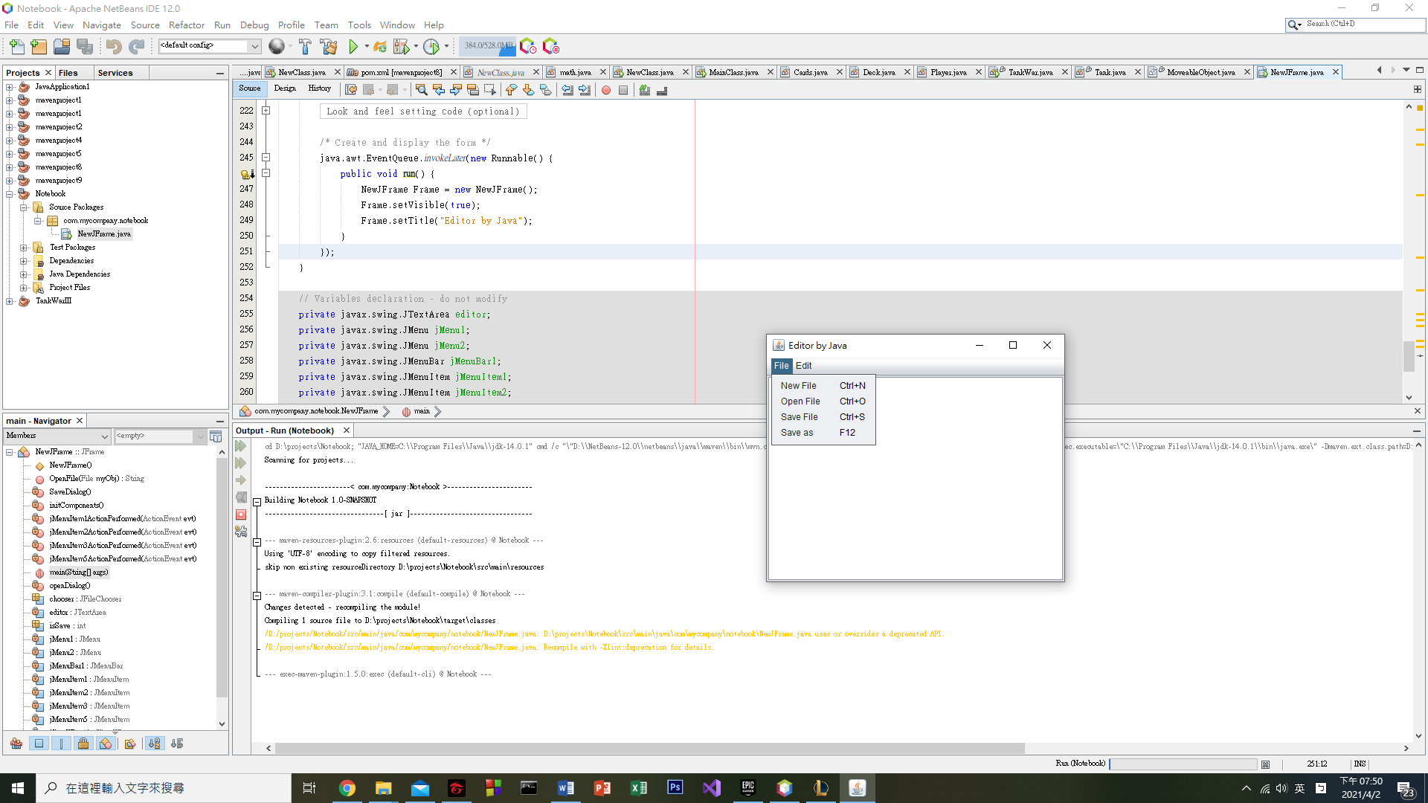

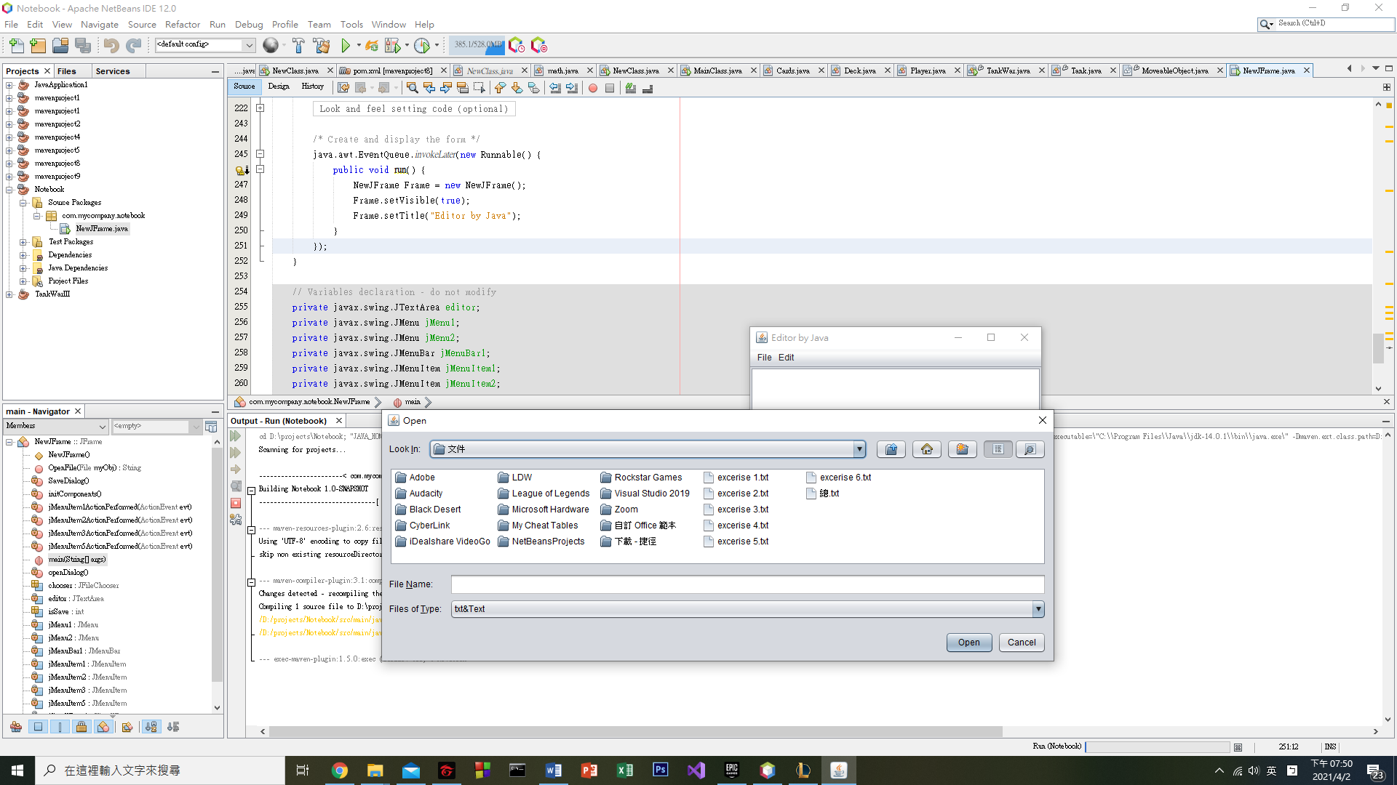

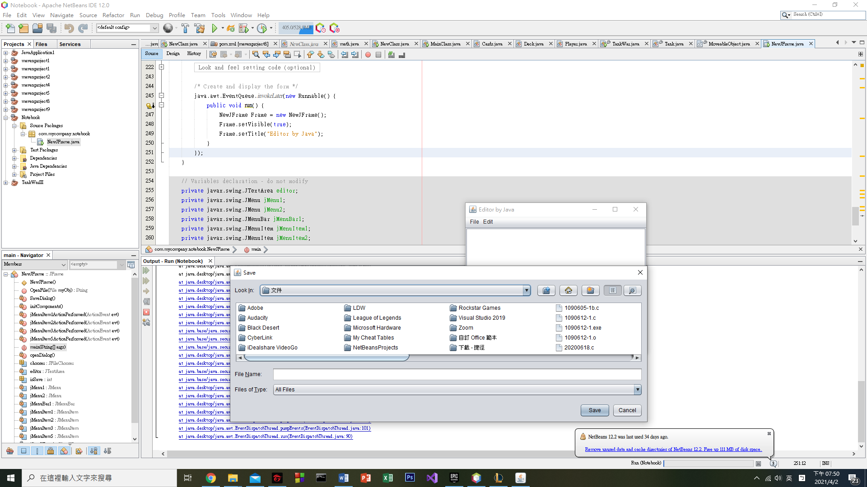

3.Lessons learned and conclusion:

After doing this homework, I learned how to make a GUI for the java application. Our program no longer only has a command line, we can set a GUI to make our program more user friendly.

At first, I didn’t know how to save the file, so I used “Open file” to save the file. This solution looked good, but that was not a good way to save the file. Because of this, I searched the Internet for the function of saving the file. I found a lot of websites tell us how to save. Finally, I succeed.

When I was doing the homework, I thought a lot, such as creating a new file, saving as a new file, and possible undesirable situations when creating a new file, so I not only used function, but also used some if else expression.

I got a lot of self-confidence of programming Java, I hope I can use my Java skill to make a video game.